**Template**

Structure and comment

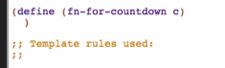

Go to recipe

* 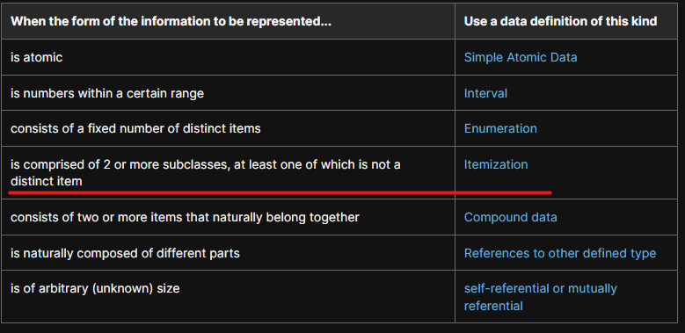
* 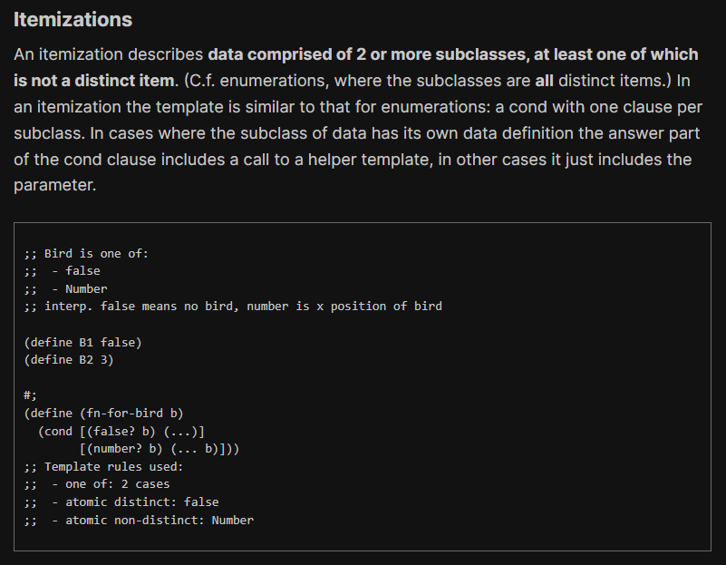
* 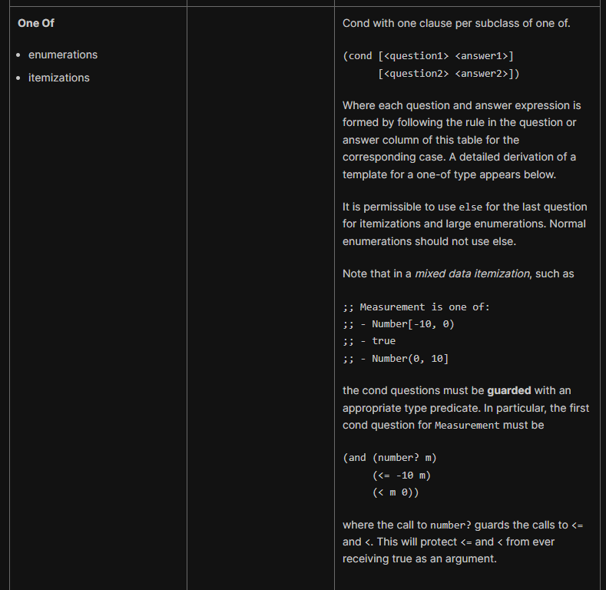

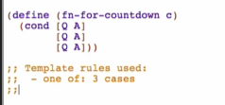

First case (false): [Q A]

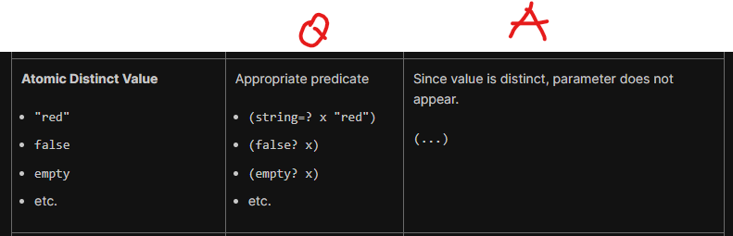

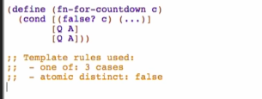

2nd case (interval: Natural [1, 10]): [Q A]

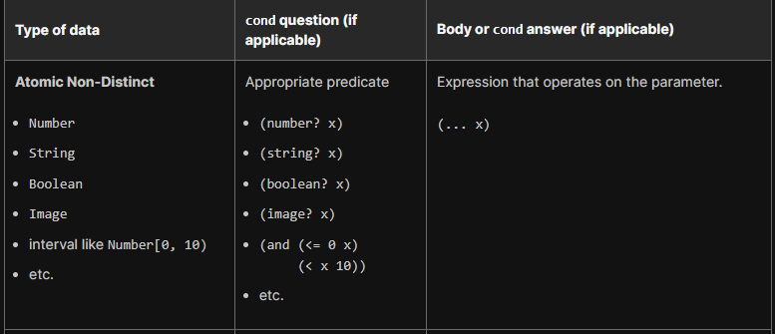



* Mixed data itemization

So you cannot really use this template directly: 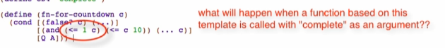

You cannot call <= for strings

We need to guard this <= to call only if you’re a number

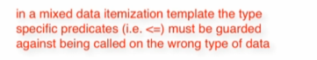



Add the template rule used

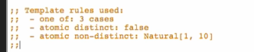

3rd case:

